Jarron Bailey

Midterm

03/17/2019

**Test 1: Loan amount is not a number = Failed**

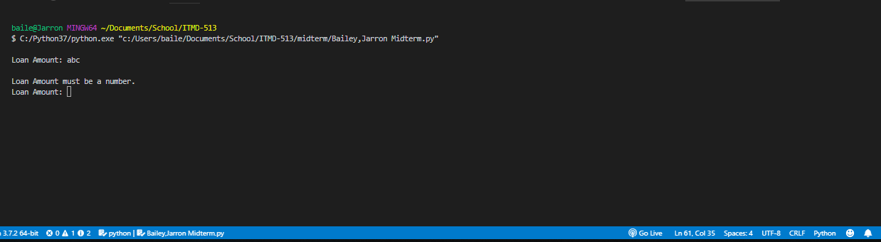

**Test 2: Loan amount less than 0 = Failed**

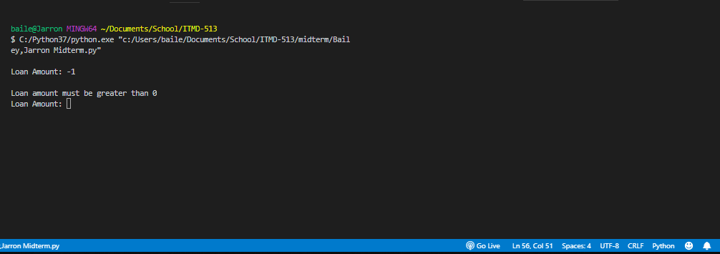

**Test 3: Loan amount equal to 0 = Failed**

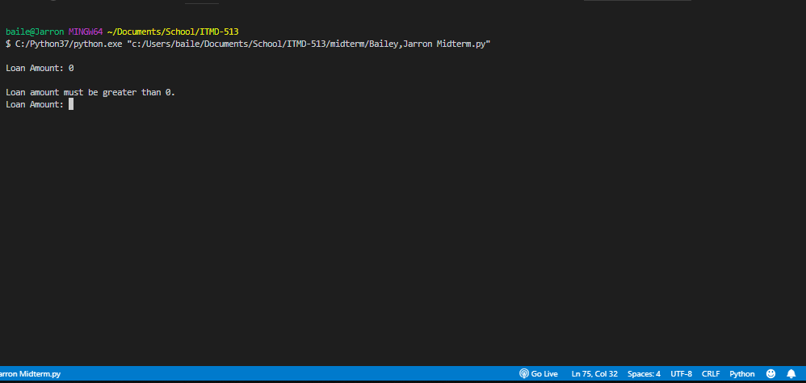

**Test 4: Loan amount as an integer = Passed**

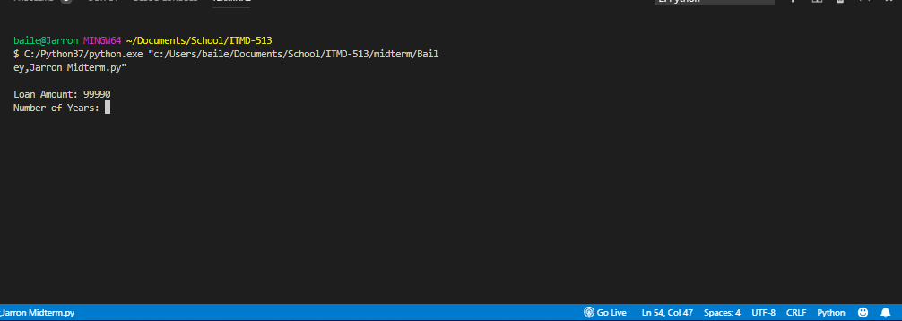

**Test 5: Loan amount as a float = Passed**

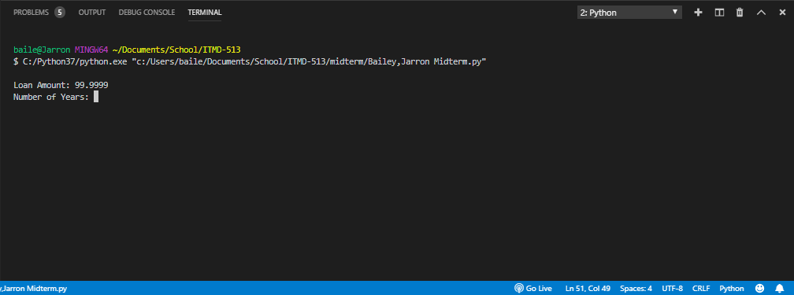

**Test 6: Number of years is not a number = Failed**

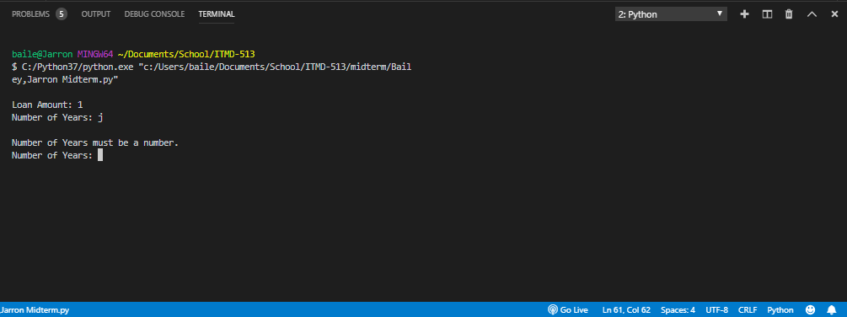

**Test 7: Number of years less than 0 = Failed**

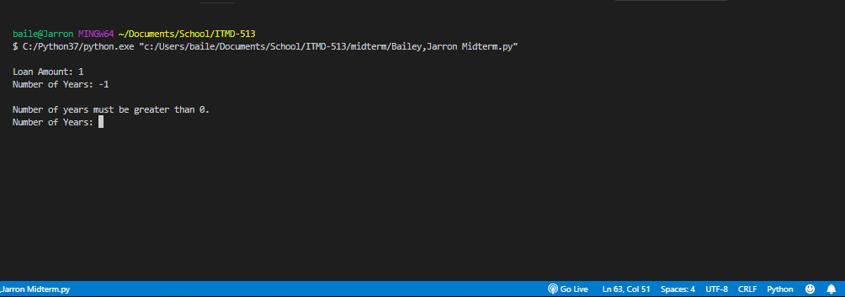

**Test 8: Number of years equal to 0 = Failed**

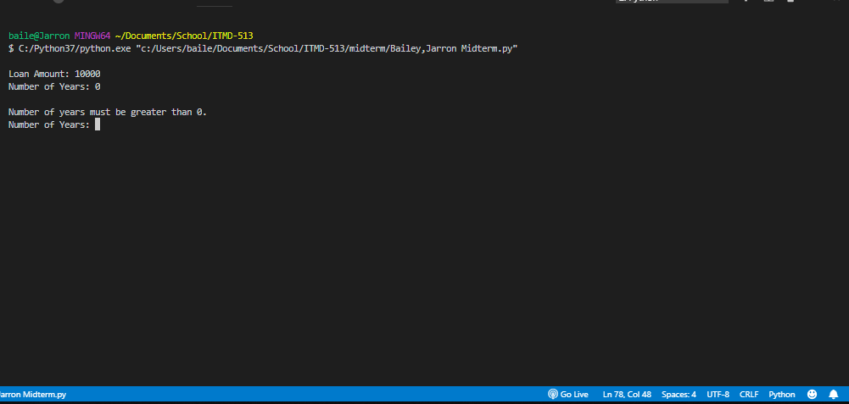

**Test 9: Number of years as an integer = Passed**

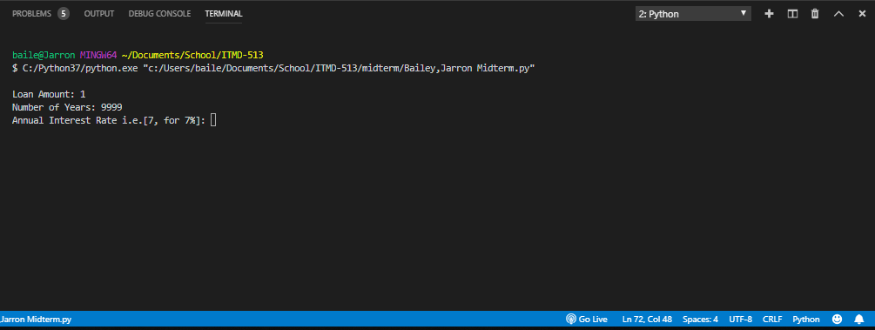

**Test 10: Number of years as a float = Passed**

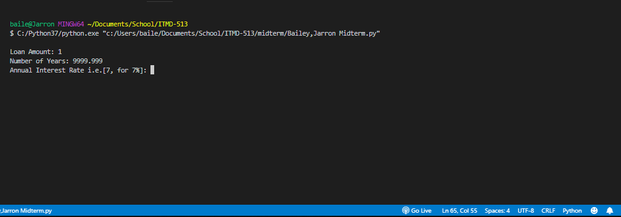

**Test 11: Annual interest rate is not a number = Failed**

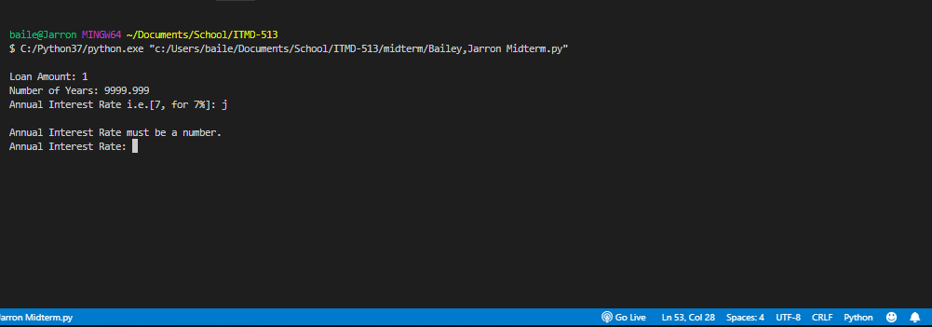

**Test 12: Annual interest rate less then 0 = Failed**

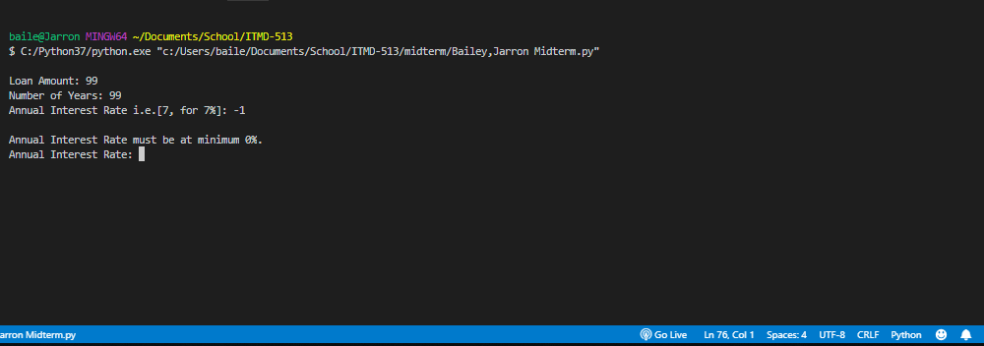

**Test 13: Annual interest rate equal to 0 = Failed**

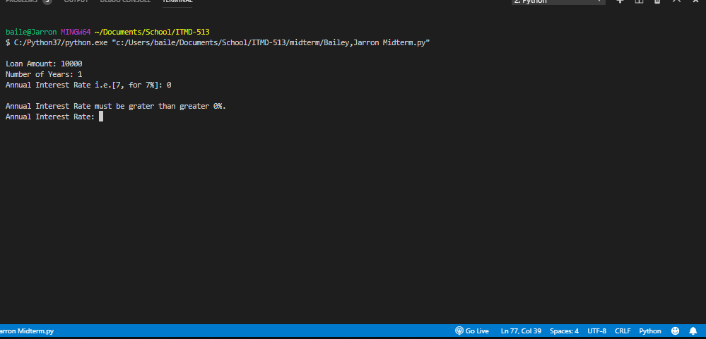

**Test 14: Annual interest rate greater than 0= Passed**

